Republic of the Philippines Laguna State Polytechnic University



Province of Laguna

**OFFICE OF STUDENT AFFAIRS AND SERVICES**

# EXCERPT OF THE MINUTES OF THE MEETING OF OFFICE OF THE UNIVERISTY WIDE STUDENT AFFAIRS AND SERVICE HELD ON SEPTEMBER 10, 2021, 2:00 o’clock IN THE AFTERNOON VIA GOOGLE MEET.

**PRESENT**

Jayson N. Olayta - Presiding Officer & Director, OSAS Dr. Alberto Castillo - Chairperson, SPC

Dr. Flora H. Salandanan - Chairperson, LB Prof. Rozalle Palacol - Charperson, SC

Jherwin P. Hermosa Maria Laureen B. Miranda

Joanna A. Erlano- De Torres Regine Olivas

Mark Gil F. Andico Sandy Jessy Lyn B. Leobrera

Winchell Ceazar R. Desamero Julieta V Alipio

Jennelyn Espinueva Chester Derequito

Celeste C. Marquez susanna.labastilla

Gelzen R. Jamolin Aubrey-Ann L. Florencio

Demterio Melvin Matulac Charmaine Wagan Ballesteros

Mary Grace P. Gallardo Reymond Nonatos Coria

Rozalle H. Palacol Francis jose dela cruz

Mary Ann Hernandez Marife P.Hosmillo

Rachiel R. Rivano Abigail Viar

Maria Agustina Rosario Bethzaida S. Decena Sandra P. Mesina

Cheerobie B. Aranas Darwin Alejandrino

Paulo M. Orioste

# Agenda:

1. ISO Document Preparation
2. Presentation of Revised OPCR Target for July to December 2021
3. Accomplishment Report (January to June 2021)
4. Status of SSC Election
5. Other Matters
   1. Status Update of Admission

# Call to Order:

1. **Discussion:**

The meeting started at exactly two o’clock in the afternoon with the opening prayer led by Paulo Orioste.

Mr. Jayson N. Olayta OSAS Director headed the meeting and presented the agendas to be discussed. Then, he asked the attendees for some suggestions if there was anything else to add to the meeting that could be further discussed. Mrs. Annalyn Delfino (Guidance Advisor), proposed

to add in the meeting the University Admission and Enrollment Status. With the motion of Mr. Ray Samueli seconded by the body, the proposed agenda was approved for deliberation.

## Welcoming of the Newly Designated OSAS Chairperson

Mrs. Rosalle H. Palacol welcomed by the body as newly designated OSAS Chairperson in LSPU Sta. Cruz Campus together with Mr. Jayson Olayta who was also recently designated as OSAS Director.

## ISO Document Preparation

Following the introduction and welcoming, the Director explained that the ISO evaluation is University Wide and will take place on Sept. 15-16, 2021 and need to prepare the papers and important documents that will be requested by the evaluators though some files are ready but incomplete. He added that, if possible, each unit under the Office of Student Affairs and Services will also be able to produce their own work instruction because this is one of the requirements in ISO but Mrs. Delfino elaborated that work instructions will be provided by the University Document Controller.

He also clarified shortly about the Survey Results and Analysis, Updated Risk Register, latest revision of Records, Minutes of the meetings and other files needed since everyone is knowledgeable and familiar in ISO preparation.

Mrs. Sandy Lobrera from Scholarship Office suggested that all offices under OSAS must be given an Organizational Chart but since many positions in the organization have changed, the Director replied that the request will be sent immediately via email when everything is fixed.

Another important topic discussed was the revision of the OPCR Target for the month of July-

December 2021. Mr. Olayta reiterated that everyone’s suggestions are welcome for best results.

*The information below contains the suggestions for the revision of OPCR in each category:*

## STRATEGIC FUNCTION

**INFORMATION AND ORIENTATION SERVICES**

**\***Define the participants who will attend in both University and campus wide orientation and lessen the target.

**\*** Since pandemic, it will be very hard to distribute printed materials such as flyers, brochures and other information materials. Suggested to distribute the materials through (e-copies) online platform. (Revised by context)

* Jumped to at least 1 online academic career guidance for the new applicants for college admission for at least 5 high schools in the Province of Laguna and since online platform it can lessen the budget needed for the activity.

# GUIDANCE AND COUNSELING

**\***Lessen the target to at least (1) one program/activity for all students, faculty and staff with at least 4.0 satisfaction rating and budget is campus share.

**\*** At least 5 individual or one (1) group of students seek guidance and counseling services.

# CAREER AND JOB PLACEMENT SERVICES

**\***Conduct at least one (1) Online Job Orientation and/or one (1) Online Job Fair with at least 4.0 satisfaction rating

# ECONOMIC ENTERPRISE DEVELOPMENT

* Conduct at least one (1) Online program/activity related to Student Economic Enterprise Development with at least 4.0 satisfaction rating and campus shared allotted budget.

# STUDENT HANDBOOK DEVELOPMENT

* At least 50% of enrolled students and university stakeholders provided a copy of student handbook.

# STUDENT ORGANIZATION AND ACTIVITIES

* Recognize at least 10 student organizations.
* Conduct at least one (1) online activity such as webinar, meetings, and other pertinent activity to ensure the effectiveness and efficiency of the services to the students.
* From 10 lessen at least 5 student organization activities monitored and supervised.

# LEADERSHIP TRAINING

**\*** At least one (1) leadership training conducted & attended with at 30% of the population with satisfaction rating of 80% (4.0).

# STUDENT COUNCIL/GOVERNMENT

**\***Suggested at least (2) activities conducted with 80% satisfaction rating from the students/participants.

# STUDENT DISCIPLINE

* At least 1 case settled per semester

# STUDENT PUBLICATION

* All campuses must simultaneously (same date/s) release their publications.
* No. of published newspaper/magazines. (At least 1 printed newspaper/journal/magazine, newsletter per semester)

**\***At least 50% of enrolled students provided a copy of newsletter, magazine per semester.

# ADMISSION SERVICES

**\***Target number of student applicants (admission and enrollment) is by campus.

# SCHOLARSHIP AND FINANCIAL ASSISTANCE

* Prepare and submit one (1) scholarship report forty (40) days after enrollment.
* Number of actual scholars and grantees monitored (by campus).

*Suggested to conduct at least 1 activity per semester.

\**Note:* Collection of submitting of reports is campus-rotation.

# FOOD SERVICES

**\***Not applicable due to pandemic.

# HEALTH SERVICES

**\*** Conduct at least one (1) online health program/activity such as webinar with at least 4.0 satisfaction rating.

*Add the target for dental per campus

*Dr. Coria asked help to Mr. Olayta for his suggestion; to allow the patients with oral/dental health issues by appointment (students/University employees) to enter the school premises following the COVID-19 Health and Safety Protocols.

*He also requested to visit all campuses.

* Assist at least students who seek medical assistance through online or tele-consultation. *( campus decision)*
* 100% sanitation program & secure water analysis certification for effective and efficient services *(every 6 months or twice a year)*

# SAFETY AND SECURITY SERVICES

**\***Mr. Ronaldo Maglapus explained that the *Safety Unit/Office* is separated from

*Security Services.*

*(Under Security Services) Conduct security online and/or physical drill within the university following the minimum health standard with at least 4.0 satisfaction rating of attendees.

# STUDENT HOUSING AND RESIDENTIAL SERVICES

*not applicable due to pandemic

# MULTI-FAITH SERVICES

* Conduct one (1) virtual program/activity *PER SEMESTER* designed to meet the needs of students in religious/spiritual aspect with at least 4.0 satisfaction rating.

# SERVICES TO SPECIAL NEEDS

**\*** Agreed to create one (1) guideline/internal policy for various groups with special needs.

# CULTURAL AND ARTS PROGRAMS

* Conduct at least one (1) virtual cultural and arts activity within the semester with a rating of 4.0 satisfaction by the participants.
* Conduct at least one (1) training for student artists.
* Attendance to local, national and international cultural/historical celebrations. (online)

# SPORTS DEVELOPMENT PROGRAM

* Agreed to conduct at least one (1) individualized physical fitness program through online platforms with the satisfaction rating of 4.0.

\**Plan on October*: more on recruitment and series of competition per campus discussed by Mr. Darwin Ofrin.

# SOCIAL COMMUNITY INVOLVEMENT PROGRAM

* The activities are still under planning because the Unit is not active due to the pandemic**.**

**\***Agreed to conduct at least one (1) online community-based program related to student development.

The categories under Support Function are no longer discussed because the Unit Heads already knew what to do in preparation of its document.

After a long discussion on the revision of the OPCR, OSAS Chairpersons have prepared for their presentation of the Accomplishment Reports from the month of January to June 2021. Mrs. Flora Salandanan of Los Banos led the presentation, followed by Mr. Albert Castillo of San Pablo and lastly Mr. Jayson Olayta presented the Accomplishment Reports of Sini loan and Sta Cruz Campus.

Regarding the status of Supreme Student Council Election, the OSAS Director explained why the Federated Supreme Student Council issued an Advisory regarding the extension of University Wide SSC Election. He clarified to everyone that everything must be arranged first before it can proceed due to these reasons: No COMELEC formed before posting the list of candidates, Unsigned COC and Single Party was formed. Generally, everything went well and the information about the Election was shared to the students of the University through the online platform.

University Admission and Enrollment status was the last topic everyone talked about raised by Mrs. Annalyn Delfino. They shared their experiences regarding the difficult transaction in admission, application screening, enrollment etc. She suggested to the Director that if possible help them to escalate this problem to superiors to fix the struggles in the admission and enrollment system. This is also for the good service they can provide for the students and the University.

The meeting was ended vigorously and productively.

# Adjournment

Meeting adjourned at 5:30 in the afternoon.

# Photo(s):

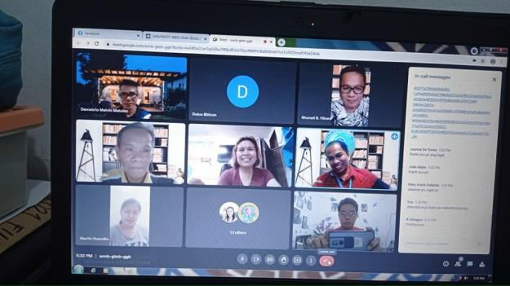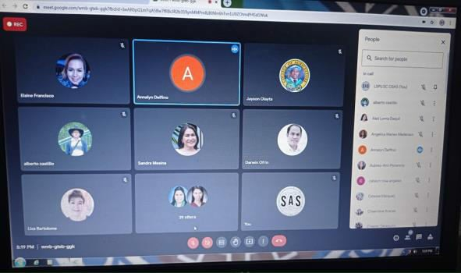

Prepared by: Noted:

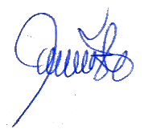

# PAULO M. ORIOSTE JAYSON N. OLAYTA

*Acting Secretary OSAS Director*